Tarot Cards
Becky Rysinski
The following is an interpretation of my life, in the present, past and future, through reading Tarot Cards. The Tarot Card pictures and text are vague, but the specificities are well chosen. For example, the card signifying “new instruction” can apply to just about anything, but can prompt someone to reflect about a particular event. Any card can reveal something about a personal moment, goal or belief. Like reading words on a scrabble table, Tarot Cards “make sense.” The messages are sometimes funny, sometimes relieving and sometimes sad. This project is an exercise in interpretation in order to find meaning and to reflect on my life.
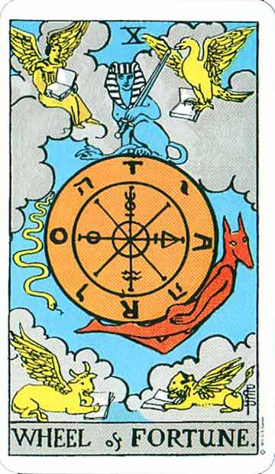

Note: I consulted the “Rider Waite Tarot Deck” (original drawings by Pamela Colman Smith under direction of Arthur Edward Waite) and referred to 21 Ways to Read a Tarot Card by Mary K.Greer.
The Tarot Card Reading:
I came up with the following question because I had just applied to Teach for America, an organization that sends college graduates to work in inner-city and low-income schools. (In January, I find out if I get in.) It is my first choice after I graduate, and is certain to be a life-changing experience. It means a lot to me, so I thought it would the best inquiry to ask the Tarot Cards and would provide meaningful interpretation.
The question is: If I get into Teach for America, what will my experience be like?
- The Spread of the Tarot Card Reading – page 3
- The Tarot Card Reading
  - Present Position – page 4
  - Immediate Obstacles – page 5
  - Future Goal or Destiny – page 6
  - Distant Past – page 7
  - Recent Past – page 8
  - Future Obstacles – page 9
  - You in Regard to the Question – page 10
  - Environmental Factors – page 11
  - Inner Emotions – page 12
  - Final Outcome – page 13
- Final Interpretation and Conclusion – page 14
- My Own Tarot Card Illustration – page 15

The Tarot Card Spread:

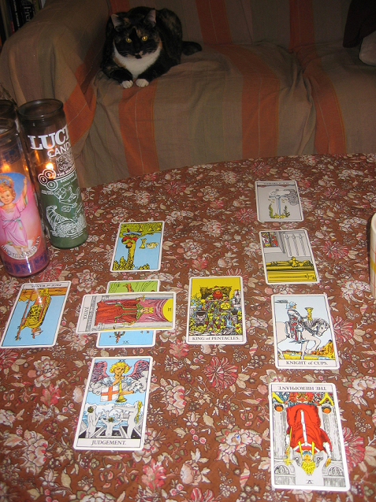

1. Present Position: 6 of Wands, reversed

Description: Apprehension, fear - as of a vicious enemy at the gate; treachery, disloyalty, as of gates being opened to the enemy.
Background color: Blue - Truth, spirituality, calmness, peace, serenity, fidelity, heavenly, cold, melancholy, depression (Greer 144).
Suit: Wands - Radiant, energetic, passionate, courageous, enthusiastic, desiring, aggressive, willful, optimistic (Greer 52).
Number: 6 - Six represents emerging consciousness and purification (Greer 44).
My explanation: I suppose that this must reflect my apprehension of joining an organization like Teach for America. It is extremely hard work, and I have general fears about working in a low-income school when it comes to classroom management and making sure my students perform up to the appropriate grade level. As for as a vicious enemy being at the gate, and treachery and disloyalty, maybe this is my apprehension that the Teach for America recruiters and leaders will have too high expectations and I will feel as if I do not have their support. The meaning behind number 6 makes sense to me - I am formulating new thoughts about my future and joining TFA is at the forefront. The words associated with wands also accurately show my attitude about undertaking this new challenge, such as my efforts in the long interview we all had to go through. (It first consisted of an online application, a phone interview, then a day-long group interview and final one-to-one personal interview.) As for the background color of blue, this one is a stretch. I am apprehensive, yet energetic and optimistic, but the background color suggests I'm also calm. Maybe the "peace" and "truth" words in the list represent what I will get out of the TFA experience, or what I want to get out of it.

2. Immediate Obstacles: Justice
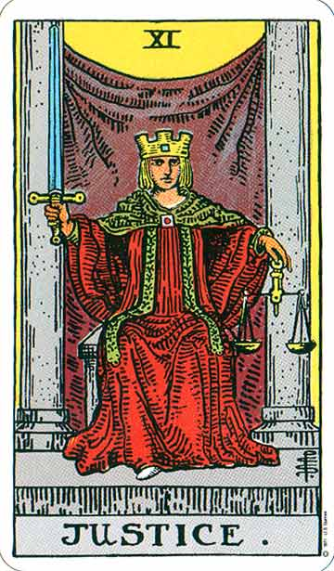
Description: Equity, rightness, probity, executive.
Background color: Yellow – Intellect, brightness, light, happiness, confidence, fear, cowardice, bitterness, deceit (Greer 144).
My explanation: This card works fairly well in reflecting my immediate obstacle. At the time I did this tarot card reading, my final interview was coming up during the next week, so I think that is what this card refers to. Rightness and probity refers to how I carried myself during the interview (I was honest and direct) and equity and executive reflects the values that I related to the interviewers. I suppose that the first half of the words corresponding to the color yellow, (I believe the next half is if the card is reversed), also reflect my attitudes during the interview. Overall, I think that this card reflects the process of getting into Teach for America, and that my actions and character will guide me in my experience.

3. Future Goal or Destiny: 4 of Cups, reversed

Description: Novelty, presage, new instruction and relations.
Background color: Blue - Truth, spirituality, calmness, peace, serenity, fidelity, heavenly, cold, melancholy, depression (Greer 144).
Suit: Cups - Nurturing, receptive, sustaining, feeling, empathic, protective, merging, flowing, yielding, secretive (52).
Number: 4 - Four represents perfect order and permanence (43).
My explanation: This card works fairly well in explaining my goal. Teach for America is a prestigious program and will be a unique and life-altering experience, hence the novelty aspect. The word "presage" is interesting here since it means omen, and the question is about the future. As far as new instructions and relations go, I want to do something completely different when I graduate, and Teach for America presents a great opportunity to do so. The number four, I suppose, represents a goal of bringing permanence and structure to a chaotic classroom. The first six words associated with cups represent the qualities I think an elementary or secondary education teacher should have. The first couple of terms representing blue also show my ultimate goal in my experience for TFA - especially calmness, peace, and serenity - seems unlikely, however.

4. Distant Past: King of Pentacles
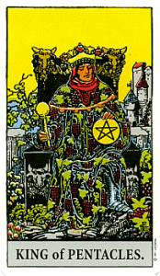
Description: Valor, realizing intelligence, business and normal intellectual aptitude, sometimes mathematical gifts and attainments of this kind – success in these paths.
Background color: Yellow – Intellect, brightness, light, happiness, confidence, fear, cowardice, bitterness, deceit (144).
Suit: Pentacles – Practical, grounded, realistic, dependable, sensuous, stubborn, cautious, persevering, possessive, protective (52).
Number: King – “A king is the mature, authoritative yang or masculine energy that commands, defines, protects. It is often associated with virility, aggression, and rationality, and indicates mastery and experience expressed in an outer or public way but sometimes statically” (40).
My explanation: Since this card describes distant past, I interpret it as describing my academic career from elementary school up into college. I have always been a good student and the word “valor,” though quite strong, may represent the work I put in to succeed. Also, business and normal intellectual aptitude suggests that I was never a prodigy, but worked hard and achieved my educational goals. The color yellow also represents my characteristics as a student, such as intellect, brightness and confidence. Also, the suit of pentacles and the King reflect my values, such as practicality, being grounded and rationality in relation to my schoolwork. My success in school has definitely affected my decision to apply for Teach for America and has shaped my reasons for wanting to participate. I have always valued education, and I want my students to get the most out of school that they possibly can. Also, doing well in school has also given me the chance to participate in Teach for America since it is so selective and pays close attention to grades and past achievement.
5. Recent Past: Judgment

Description: Change of position, renewal, outcome.
Background color: Blue - Truth, spirituality, calmness, peace, serenity, fidelity, heavenly, cold, melancholy, depression (144).
My explanation: Again, this card works very well with my recent past. Change of position, renewal and outcome describe my newfound desire to become a teacher. For about two years, I wanted to graduate and go directly into publishing. I even have a publishing emphasis in my major and a technical writing minor. However, last summer I both worked for State College Magazine and the Undergraduate Writing Center. I found myself loving the Writing Center and hating the magazine. So, up until very recently I discovered that I wanted to be an instructor and work in education, and Teach for America seemed like a great opportunity directly following college. The words associated with blue such as truth, spirituality, and calmness demonstrate that I am mentally certain and at peace with my decision to become a teacher.

6. Future Obstacles: Page of Wands reversed

Description: Anecdotes, announcements, evil news. Also, indecision and the instability which usually accompanies it.
Background color: Blue - Truth, spirituality, calmness, peace, serenity, fidelity, heavenly, cold, melancholy, depression (144).
Suit: Wands - Radiant, energetic, passionate, courageous, enthusiastic, desiring, aggressive, willful, optimistic (52).
Number: Page – “A page, in terms of rank, is about newness. It represents the beginning of an endeavor, a tentative experience, and serving others. It indicates initiatory, immature, innocent, open, and curious energies. Pages may bear messages” (40).
My explanation: Once again, this card seems to fit really well in describing future obstacles. For example, the Page represents the experience of becoming a new teacher – such as the “beginning of an endeavor, a tentative experience and serving others.” It also indicates immaturity and innocence, and I will no doubt be mature enough to handle my first couple of classes. As for the description, I think that evil news and announcements represents the reality of teaching in an inner-city classroom, and I will be unsure of whether or not I want to continue doing it. Since the card is reversed, cold, melancholy and depression are probably what I will feel in my first couple of weeks or months as a new instructor. However, the words associated with wands give me the feeling that I will persevere and remain optimistic through this difficult time.

7. You In Regards to the Question: the Hierophant reversed
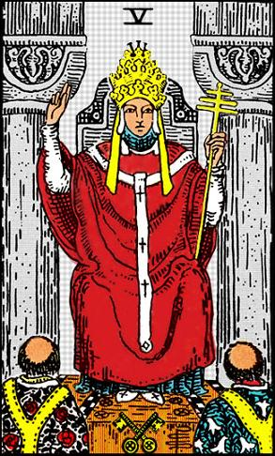
Description: Society, good understanding, over-kindness, weakness.
Background color: Gray – Neutrality, balance, reconciliation, penitence, poverty, indifference, hardness, sadness, loneliness (144).
My explanation: Since this card is about me, and it is pretty harsh, I am a little more reluctant to “believe” what it reveals. However, it does lend some insight into my current position and how I feel my Teach for America will pan out. First of all, I think that society and good understanding may reflect my desire to make a difference and to be a great teacher for students who need education. However, the over-kindness and weakness part of the description may be signifying that my expectations are not realistic, and that I will only see the reality of inner-city schools once I start working there. Since the card is reversed, the words poverty, indifference, hardness, sadness and loneliness describe me. Perhaps these words signify my fears and how I imagine or predict I will feel when undertaking this project.

8. Environmental Factors: Knight of Cups

Description: Arrival, approach – sometimes that of a messenger; advances, proposition, demeanor, invitation, incitement.
Background color: Blue - Truth, spirituality, calmness, peace, serenity, fidelity, heavenly, cold, melancholy, depression (144).
Suit: Cups - Nurturing, receptive, sustaining, feeling, empathic, protective, merging, flowing, yielding, secretive (52).
Number: Knight – “A Knight is like an adolescent, pushing boundaries, extending experience, and testing abilities. This rank indicates adventurous, exploratory, revolutionary, and goal-focused energies. It suggests action, movement, and development. Knights can also indicate journeys” (40).
My explanation: This card works very well in describing environmental factors. I interpret this as a description of the Teach for America recruiter who got me interested in Teach for America in the first place. When I first applied, I was not completely serious about it, and it was not one of my first choices. However, I was scheduled to meet with the TFA recruiter, I’ll call him Alex, who motivated me to finish my application and gave me confidence that I would be a great candidate for the job. “Arrival, approach – sometimes that of a messenger” describes Alex in relation to my enthusiasm in applying. Also, he invited me to join TFA, so “invitation” and “incitement” definitely describe this. Again, blue comes up as the main background color. The suit also seems to describe Alex himself, as he is someone that I can trust and go to for advice. He presents himself as friendly, trustworthy, and easy to relate to. Lastly, the Knight represents the recruiter’s actions in his undertakings as both a Teach for America alum and as a recruiter, and his drive to get as many people as possible to join the organization.
9. Inner Emotions: 4 of Swords
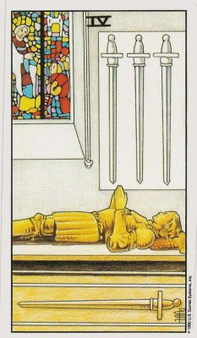
Description: Vigilance, retreat, solitude, hermit’s repose, exile, tomb and coffin.
Background color: Gray – Neutrality, balance, reconciliation, penitence, poverty, indifference, hardness, sadness, loneliness (144).
Suit: Swords – Mental, logical, rational, communicative, inquisitive, alert, fair, clever, nervous, impersonal (52).
Number: 4 - Four represents perfect order and permanence (43).
My explanation: Supposedly, the 4 of swords reflects my inner emotions. However, I am not sure if this actually reflects my feelings about Teach for America. At the same time, the Tarot Card presents plenty of words that vary in degrees, so it vaguely relates and can be interpreted. As far as “vigilance” and “retreat” go, I can only say that by putting all of my hopes in Teach For America, I may be shutting myself off from other adventures. Of course, if I don’t get in I will have time to decide what I will do after I graduate, but for now I am not exploring other options. Since the words associated with gray are mostly related to neutrality or indifference, they do not accurately reflect my inner emotions – honestly, at the time, I was feeling excited and nervous about Teach for America. Of course, nervous comes into play with swords, which also states I am mental and logical – perhaps I consider involvement in TFA to be a rational decision, which also goes along with the meanings behind the number 4.

10. Final Outcome: Ace of Swords reversed
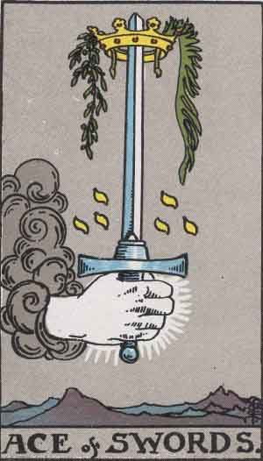
Description: Triumph, the excessive degree in everything; conquest, triumph of force. A card of great force, in love as well as hatred. The results are disastrous; another account says conception, childbirth, augmentation, multiplicity.
Background color: Gray – Neutrality, balance, reconciliation, penitence, poverty, indifference, hardness, sadness, loneliness (144).
Suit: Swords – Mental, logical, rational, communicative, inquisitive, alert, fair, clever, nervous, impersonal (52).
Number: Ace reversed – Delays; opportunities not grasped; impotency; materiality; inner focus; pre-conscious (245).
My explanation: Needless to say, I was not happy to see this card as a final result. According to this card, if I get into Teach for America, I will try to succeed in bringing my kids up to grade level, controlling the classroom, etc. by too much effort or force, and it will not work. (I don’t think the conception and childbirth part of the description applies here – unless there is a multiplicity of ideas, but this seems unlikely.) According to Greer’s book, upside-down Aces signify failure to take an opportunity. I can only imagine that is reading is saying that my efforts will not work, and that my classroom experience will be a disaster. If I can take anything away from this card, it would be not use drastic or excessive force in order to achieve my goals.

Final Interpretations and Conclusions about the Tarot Card reading:
Now, it is time to look at the “big picture.” There are some general trends in the whole Tarot Card reading that I wish to explore. First of all, half of the cards had a blue background, signifying “truth, spirituality, calmness, peace, serenity, fidelity, heavenly, cold, melancholy, depression.” When asking about Teach for America, it seemed odd to me that this color came up so much, when I generally feel anxious, scared, and excited about the prospect. However the words, that is, the first half of them, seem to reflect my overall disposition in wanting to be a teacher and wanting to make a difference. Perhaps this means that my experience with Teach for America will be a cathartic one. Essentially, I will feel accomplished and at peace with myself if I do something to give back to the community.
At the end of the Tarot Card reading, the background color was gray when depicting “Me in Regards to the Question,” my “Inner Emotions,” and the “Final Result.” Because gray signifies “neutrality, balance, reconciliation, penitence, poverty, indifference, hardness, sadness, loneliness,” it seems to work together with the blue, and that I will be at peace with these emotions. I expect that whatever I go through in Teach for America will completely alter my worldview – I will have to remain level-headed if I am going to get through it. Also, a change in my worldview may bring balance and reconciliation with my previous understanding, and I will certainly see poverty, if not experience it myself. Though gray seems to be a more negative color, it also makes sense in the context of Teach for America.
Overall, the Tarot Card reading seemed to be accurate, especially in the beginning. The cards that made the most sense to me were about the present: “Future Goal or Destiny,” “Distant Past,” “Recent Past,” and “Environmental Factors” and “You in Regard to the Question.” Because these descriptions allowed me to make clear connections to particular events in my life, it led me to believe that the cards predicting my future, such as “Future Obstacles” and “Final Outcome” were also very telling, even though there is no way of knowing. The Tarot Cards that “worked” also help me to forget the cards that didn’t. Overall, I would say that this Tarot Card reading had a balanced mixture of wands, pentacles, swords, cups, and face cards (of the Major Arcana – a story made up of the face cards in the Tarot deck), and both negative and positive cards, which led me to truthfully and accurately interpret my life in regards to Teach for America.

My Own Tarot Card Illustration
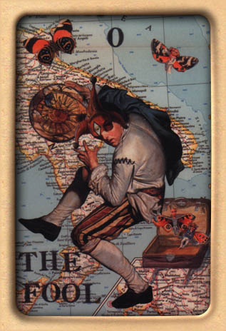
Pamela Colman Smith Red Dog Scott Paola Angelotti
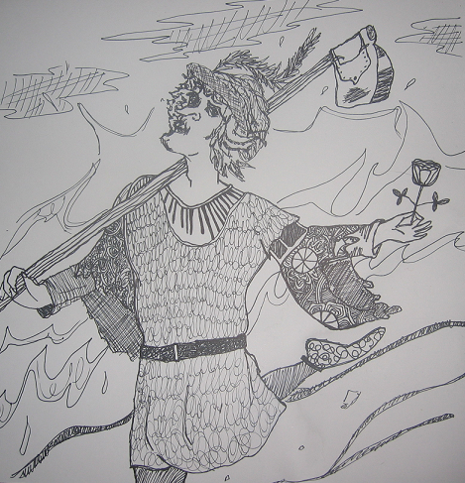
Becky Rysinski
“The Fool” – A card that stands for “folly,” but also “a new beginning.”

